NAME____________________________LAB MEETING DAY/TIME______________

Lab 8: Proterozoic and Paleozoic North america - KEY

In this lab you will continue to examine geologic maps and explore the development of the North American continent in the Proterozoic and Paleozoic. You will be completing Exercises 14 and 15 in your lab manual.

# **Exercise 14, Part A**

**Answer the questions indicated below; you may skip questions 4, 5, 7, 9, and 10. The goal of this part is to refresh your memory on the building of the North American craton.**

**Question 1:**

***Archean terranes (> 2.7 billion years or 2.7 Ga) include the Wyoming, Superior, Sauk, Hearne, Rae, and Nain provinces.***

**Question 2:**

***Approximately 25 to 30%. This may be difficult for students to eyeball, but an approximation is acceptable as the main point of the question is for students to recognize that only a nucleus of the North American continent existed during Archean time.***

**Question 3: Research “Abitibi Belt” online to answer this question. Also answer the question, what resource is found in this belt?**

***The Abitibi Belt is a greenstone belt, 2.8-2.6 billion years old, made of igneous rocks, known for gold deposits***

(<https://en.wikipedia.org/wiki/Abitibi_greenstone_belt> and <https://en.wikipedia.org/wiki/Abitibi_gold_belt> )

**Question 6:**

***Figure 14.2 shows that the Archean cratons and provinces form the center of the continent and that newer belts of continental rock were added along the margins in more recent periods. Examples include the Yavapai Province and the Wopmay and Thelon belts.***

**Question 8:**

***Figure 14.2 shows that four large provinces were accreted by collision, uplift, then erosion along the southeast margin of ancestral North America during Paleoproterozoic to middle Mesoproterozoic time.***

***These are, sequentially, the Yavapai Province (1.76 to 1.68 Ga), the Mazatzal Province (1.68 to 1.65 Ga), the Granite and Rhyolite Province (1.55 to 1.45 Ga), and the Grenville Province (1.3 to 1.0 Ga). The Paleozoic orogenies follow this pattern.***

***Students should give a larger percentage than they reported in question 1, recognizing these provinces added land to the continent.***

# **Exercise 14, Part B**

**The goal of this part is to review the major sedimentary basins of North America.**

**Question 1:**

***The thickness ranges from a few meters thick at the margins to over 6,000 m thick in the eastern United States (Appalachian Basin) and in the south-central United States (Anadarko Basin). On average, though, sedimentary cover is less than 2,000 m thick.***

***The sedimentary cover is thickest in sedimentary basins and the two basins with the thickest sediment accumulations are the Appalachian and Anadarko Basins.***

**Question 2: For this question, your TA will assign your group a basin/basins to research and report upon.**

***Students should fill this out using a team effort, where you as the TA assign small groups each basin, and have them write their results on a document displayed on the doc cam.***

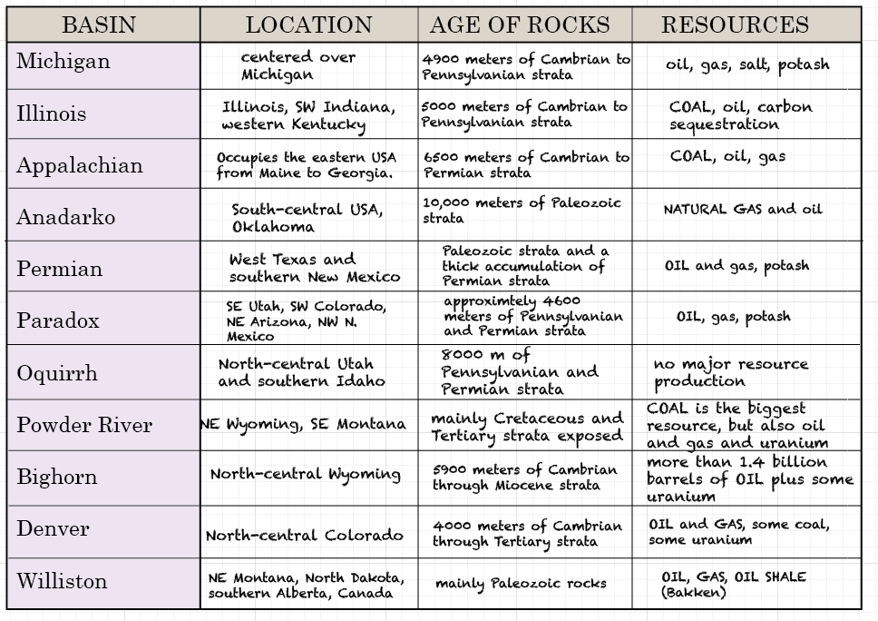

**Question 3:**

***The Adirondacks, located in the east-central portion of figure 14.3, are an exposure of 1.3 to 1.0 billion-year-old rocks that comprise a portion of the Grenville Province of figure 14.2.***

**Question 4:**

***Rocks exposed in the uplifted core of the Bighorn Mountains are colored light pink on the map and correspond to the position of the Wyoming Province on figure 14.2. These rocks are 3.8 to 2.8 billion years old.***

***Rocks in the center of the Black Hills are colored blue on the map, corresponding to the color and pattern of the Yavapai Province on figure 14.2. These rocks are 1.76 to 1.68 billion years*** ***old.***

**Question 5:**

*By referring to figure 14.3, we once again see that Precambrian rocks are represented by the same blue color that represents Precambrian rocks in the core of the Black Hills structural dome. Hence, the Precambrian rocks seen in figure 14.4* ***are part of the 1.76 to 1.68 billion-year-old Yavapai Province.***

# **Exercise 15, Part A**

**Question 1:**

*The main rock types are phyllite and schist, metavolcanic rocks, metasediments, and igneous intrusive rocks.* ***The answer should be metamorphic and igneous rocks.***

**Question 2:**

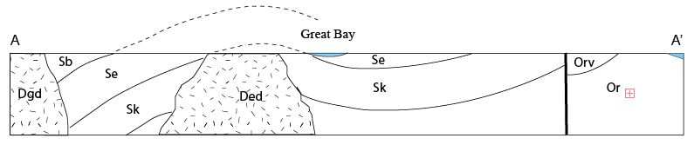

**SKIP QUESTION 3**

*The answer is that we cannot determine the fault type from the information given.*

**Question 4:**

Ordovician and Silurian rocks have been metamorphosed, so deformation was post-Silurian in age. Intrusive activity occurred during the Devonian Period, so the most likely time of deformation was during the Devonian time. **The Devonian-age deformational event that affected the map area was the Acadian orogeny.**

**Question 5:**

***Convergent. Compressional stresses indicated by the anticline and syncline; granitic intrusions are associated with plate subduction at convergent margins.***

# **Exercise 15, Part B**

**Question 1: The table is completed here for you. Take a minute to review this before moving on to the next question.**

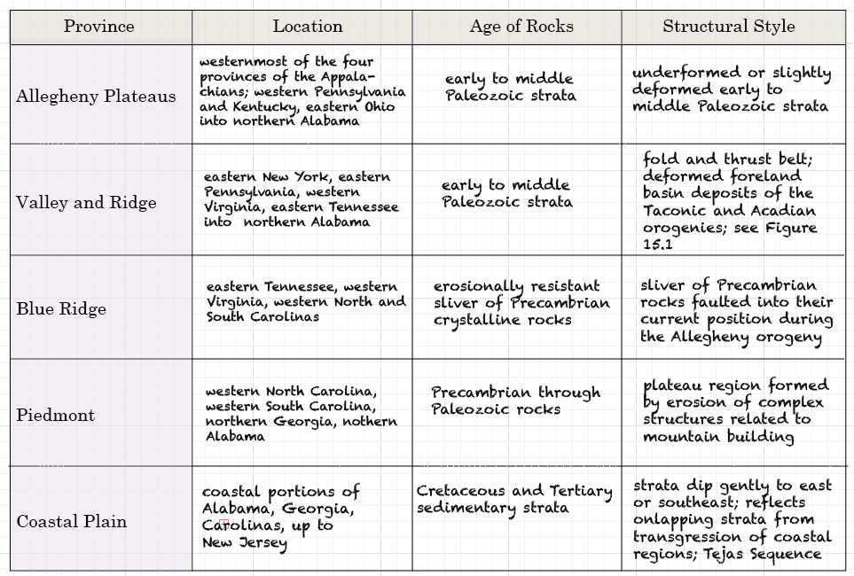

**Question 2: The map below is lightened from the one in your text, to allow easier drawing of the provinces.**

***Students should outline and label the provinces on the map, as in this example:***

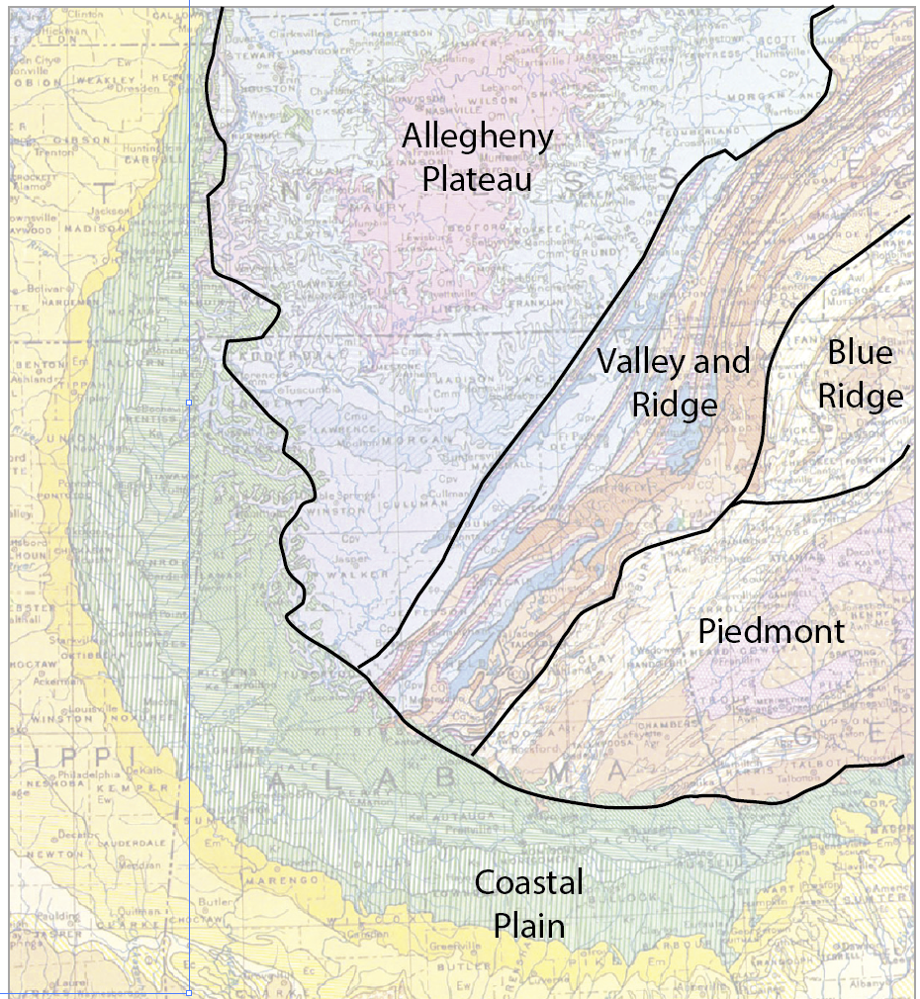

# **Exercise 15, Part C**

**Question 1: These formations are deposits from eroded rocks of mountains. Think about the orogenies of the Paleozoic, and decide which orogeny made the mountains that are the source area for the formations in the question. You might find it helpful to review the timing and location of major Paleozoic orogenies in your textbook (page 197, figure 10.3).**

***The Martinsburg and Juniata Formations (late Ordovician) formed from rocks of the Taconic Orogeny.***

***The source for the Devonian Foreknobs and Hampshire Formations (late Devonian) are likely rocks from the Acadian Orogeny.***

**Question 2:**

***The northern part of the map represents tight anticlines and synclines developed in Paleozoic rocks (Valley and Ridge province).***

***South of the turnpike (Piedmont province), faulting of Paleozoic rocks predominates.***

***There are also intrusions of igneous rocks in the SE portion of the map.***

**Question 3:**

***Folded Pottsville Sandstone gives the oldest possible date for orogeny as Pennsylvanian; unconformable relationship of Triassic formations indicates the youngest limit.***

**Question 4:**

***Triassic intrusions in southeast corner of map; rifting of Pangea.***

***Precambrian igneous rocks (mr, vs, and mb) in south-central part of map area. Precambrian mountain building; Grenville orogeny.***

**SKIP QUESTION 5, the answer is that the river formed much later, after erosion of the folded rocks.**

**Question 6:**

***Convergent, folded rocks, anticlines and synclines***

# **Exercise 15, Part D**

**Question 1: For this question, review Figure 15.5 to understand the layering of rocks, but in the cross section below, draw the relationships between the Precambrian, Mesozoic, and Permian rock. In other words you don’t have to draw the individual layers of rocks.**

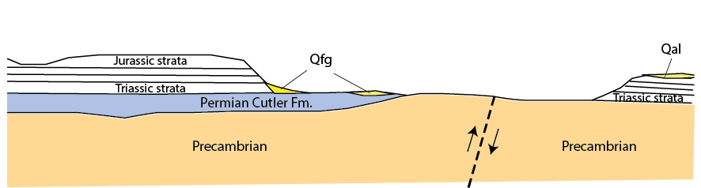

***Students only need to identify/draw the Precambrian (orange), Permian Blue), and Mesozoic strata (white).***

**Question 2:**

***The sedimentary Cutler Formation overlying crystalline rocks of Precambrian age indicates that this is a nonconformity.***

**Question 3: In other words, what might be a reason there are no Permian rocks between the Precambrian rock sand the Mesozoic strata? What might have caused this unconformity?**

***This indicates that during late Permian and early Triassic time, the area in question was structurally high and undergoing erosion while deposition took place to the south and southwest portion of the map area.***

**SKIP Question 4**

**Question 5: Think about the rock units and their characteristics for this map and cross section. Put the following events in order, from oldest (9) to youngest (1).**

__***2***__ Cenozoic uplift and erosion

__***7***__ Deposition and subsequent erosion of early- to mid- Paleozoic strata

__***9***__ Precambrian mountain building

__***1***__ Quaternary sediment depositionv

__***5***__ Deposition of Chinle and Moenkopi Formation

__***8***__ Erosion of Precambrian mountains

__***3***__ Deposition of Burrow Canyon formation

__***6***__ Deposition of alluvial Cutler Formationv

__***4***__ Deposition of Jurassic strata

# **Lab 8 Reflection**

**What concepts were most difficult in today’s lab activities?**

**What concepts were easiest to grasp?**

**What questions did today’s activ ities make you think of? What do you want to learn more about?**